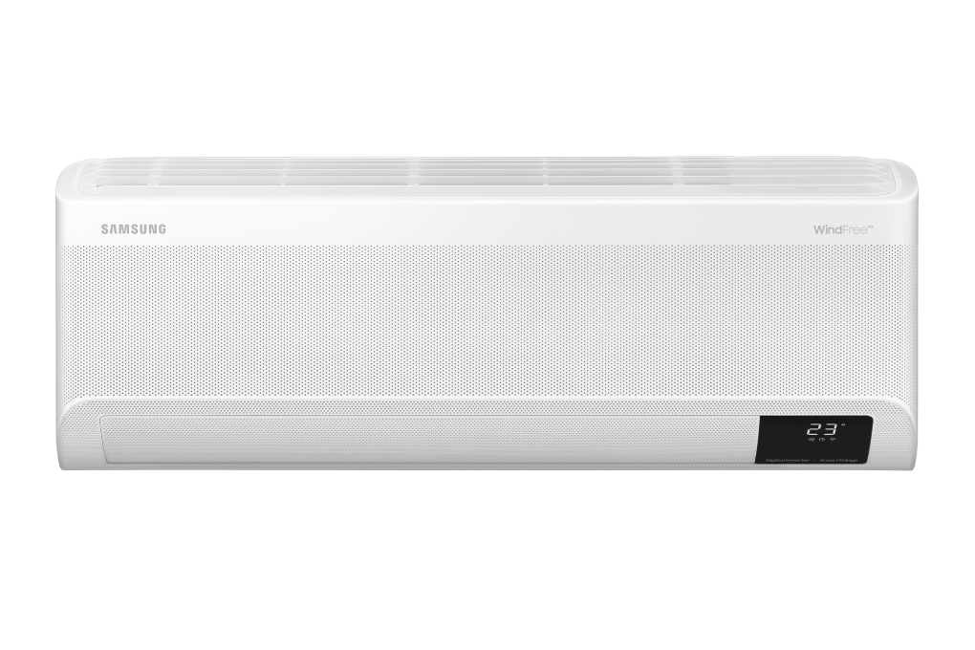

**11.390.000₫**~~12.990.000₫~~ (-12%) Online Too Cheap**11,390,000 VN**Finish on23:

**Promotion worth 1,300,000 VND**

Prices and promotions may end earlier than expected

first

Choose 1 of the promotions:

- No copper pipes and supplies will be given away.  
- Delivery only, no installation.

- Free Combo of materials (Wiring from indoor unit to outdoor unit, Simili, free up to 5 meters of copper pipes, water pipes) worth 850,000 VND (click to see details), - Free installation and [vacuuming](https://www.dienmayxanh.com/khuyen-mai/tang-vat-tu-cho-may-lanh-khong-lo-ve-phi-1234204) labor worth 450,000 VND

**Technical specifications Samsung Inverter air conditioner 1.5 HP AR13CYFAAWKNSV**

* Machine Type:

1 way (cooling only) With Inverter

* Cooling capacity:

1.5 HP - 12,000 BTU

* Effective cooling range:

From 15 - 20m² (from 40 to 60 m³)

* Dust filter, antibacterial, deodorant:

Copper Anti-bacteria Filter

* Power saving technology:

Digital Inverter BoostEco

* Rapid cooling:

Fast Cooling

* Utilities:

Good Sleep mode Wind-Free mode for comfortable cold air Dehumidification function Auto Clean function Self-cleaning function On-off timer Smart refrigeration AI Auto Cooling Temperature display screen on the indoor unit Auto-start Restarts when there is power. Remote control via SmartThings application

* Power consumption:

1.16 kW/h 5 stars (Energy efficiency 4.60)

* Cooler:

Length 82 cm - Height 29.9 cm - Thickness 21.5 cm - Weight 9.2 kg

* Outdoor:

Length 72 cm - Height 54.8 cm - Thickness 26.5 cm - Weight 22.6 kg

Introducing the company 

- A brand from Korea, founded in 1938.  
- Samsung is a multi-industry corporation, with a high level of brand recognition on a global scale.  
- Samsung's products range from mobile devices, home appliances, electronics,...  
- With the strength of being the brand of a global corporation, the quality of products always reaches the highest level of perfection. , good warranty should be trusted by customers around the world.

[***Samsung Inverter 1.5 HP AR13CYFAAWKNSV air conditioner***](https://www.dienmayxanh.com/may-lanh/samsung-inverter-15-hp-ar13cyfaawknsv#2-gia)***belongs to the***[***1-way air conditioner***](https://www.dienmayxanh.com/may-lanh?g=may-lanh-1-chieu-chi-lam-lanh)***line with a luxurious design, cools quickly with Fast Cooling technology, creates a gentle, pleasant breeze thanks to Wind-Free technology, ensuring the device Smooth operation, reducing power consumption with Digital Inverter Boost and Eco technology, saving time cleaning the machine with the Auto Clean self-cleaning function.***

**Design overview**

**Cooler**

- Samsung AR13CYFAAWKNSV has a modern design, elegant white tones combined with tens of thousands of microscopic holes on the front, bringing a unique and beautiful appearance to the overall design and layout space.

- There is **a temperature display screen on the indoor unit** for you to control and accurately grasp the temperature whenever you want.

**Outdoor**

- Rectangular design with thick, sturdy shell.

- Equipped with **copper gas pipes and high-strength aluminum heatsinks** , effective heat conduction, and limited corrosion during use.

**Refrigeration technology**

- Cooling capacity  **of 1.5 HP** meets the needs of use in spaces with an area of ​​​​15 - 20m² (from 40 to 60 m³).

**- Fast Cooling** technology with wide air intakes and air vents, larger fans help disperse cold air to every corner of the room in a short time, letting you feel the cool space in an instant.

**Air blowing mechanism**

- There is a custom wind blowing mechanism **that can be controlled up, down, left and right, automatically** spreading cold air throughout the room so that everyone living inside feels cool and comfortable.

[- Wind-Free](https://www.dienmayxanh.com/kinh-nghiem-hay/wind-freecong-nghe-lam-lanh-cua-tuong-lai-1068729) mode   creates a cool breeze blowing gently through 23,000 tiny holes on the front of the [air conditioner](https://www.dienmayxanh.com/may-lanh) , helping to cool quickly without causing pain, limiting heat shock and colds for people coming from outside. Enter a room with air conditioning.

**Power saving technology**

[- Digital Inverter Boost](https://www.dienmayxanh.com/kinh-nghiem-hay/may-nen-inverter-8-cuc-tren-may-lanh-samsung-2016-817570) technology   ensures the device operates smoothly, has a long life, maintains a stable temperature, cools quickly, and saves energy up to 68%.

**- Eco** mode ensures optimal cooling performance while reducing device power consumption.

- Energy label:  **5 stars**  (energy efficiency 4.60), electricity consumption **1.16 kW/h** .

**Air filtering ability**

-  This [Inverter air conditioner](https://www.dienmayxanh.com/may-lanh?g=may-lanh-inverter)  is equipped with **a Copper Anti-bacteria Filter** for strong dust removal ability, giving you fresh, comfortable air. The filter is easily removable for convenient cleaning.

**- Auto Clean** function automatically dries the heat exchanger, preventing bacteria and odors from accumulating in the machine, helping the device operate smoothly, saving time and effort for cleaning.

**Utilities**

**- Good Sleep** mode helps save energy up to 36%, allowing you to fall asleep quickly and sleep well all night.

- **Smart AI Auto Cooling** : with sensors that automatically analyze the temperature according to user habits, machine operations and room conditions, thereby adjusting the temperature to suit your needs.

- **Remote control via SmartThings application** : set up the application on your phone, you can conveniently control [the Samsung air conditioner at home even when you are somewhere else.](https://www.dienmayxanh.com/may-lanh-samsung)

-  **Dehumidifying function** : reduces moisture in the room, keeps the room dry, suitable for use on humid days and rainy seasons.

There are also modes such as:  [Auto-restart mode when power is restored](https://www.dienmayxanh.com/kinh-nghiem-hay/cac-che-do-thuong-thay-tren-may-lanh-795107#tu-khoi-dong) ,  [Timer to turn on and off](https://www.dienmayxanh.com/kinh-nghiem-hay/cac-che-do-thuong-thay-tren-may-lanh-795107#hen-gio) ,...

*It can be seen that the Samsung Inverter 1.5 HP AR13CYFAAWKNSV air conditioner, equipped with a variety of cooling, energy-saving technologies and useful accompanying utilities, will be a very worthy device for you to consider choosing for rooms from 15 - 20m².*